本文整理汇总了Python中**idc.print_operand方法**的典型用法代码示例

<https://vimsky.com/examples/detail/python-method-idc.print_operand.html>

<https://www.programcreek.com/python/example/102501/idc.GetLongPrm>

1、先学会用Virtuailor

2、搞清楚Virtuailor 的原理

3、实现ARM平台的Virtuailor

<https://www.unknowncheats.me/forum/general-programming-and-reversing/438307-finding-vtable.html#post3054996>

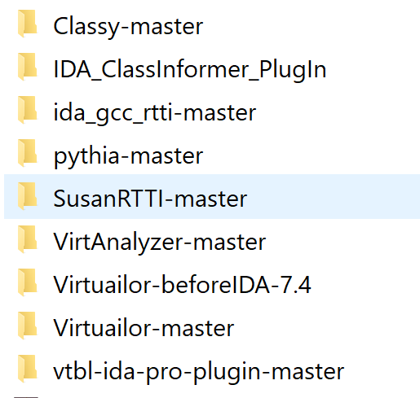

<https://github.com/RicBent/Classy>

这个貌似是ARM的

依赖sark <https://github.com/tmr232/Sark>

Python idc.print_operand方法代码示例 截取各开源项目中的用法

<https://vimsky.com/examples/detail/python-method-idc.print_operand.html>

<https://github.com/nihilus/IDA_ClassInformer>

<https://github.com/mwl4/ida_gcc_rtti>

<https://github.com/nccgroup/pythia>

<https://github.com/nccgroup/SusanRTTI>

<https://github.com/bingseclab/VirtAnalyzer>

<https://github.com/nektra/vtbl-ida-pro-plugin>

<https://www.youtube.com/watch?v=GEtpznMFsEs>

Virtuailor好像只分析了调用了的虚函数